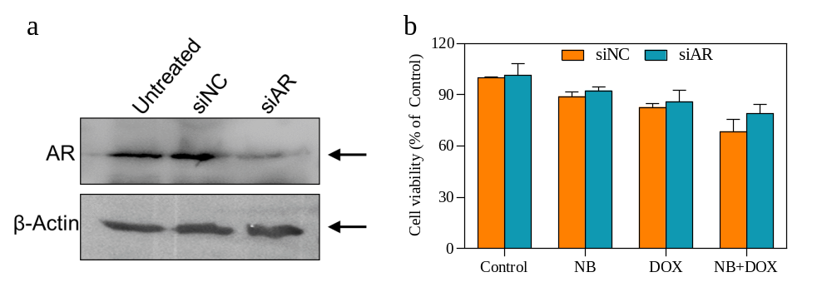Fig. s3. NB sensitizes DOX induced killing capacity is independent of androgen receptor (AR) mediated pathway. a Protein expression level of AR after the introduction of short interfering double-stranded RNAs (siRNAs). b Effects of the anticancer efficiency of NB and DOX combination treatment in AR knock down cells.

